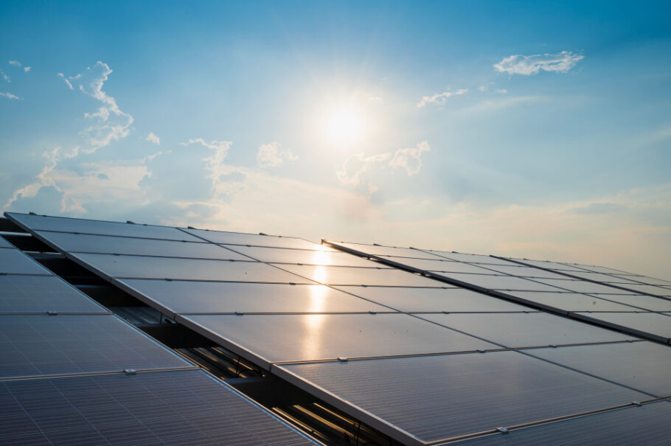

Solar Stewardship Initiative
Membership Application form

August 2025

Join the Solar Stewardship Initiative (SSI)

- About the Solar Stewardship Initiative

The Solar Stewardship Initiative (SSI) is a multi-stakeholder initiative driving sustainability and responsible practices across the solar supply chain. More information is available on our website: solarstewardshipinitiative.org.

Our Standards provide a clear and practical framework for companies to achieve responsible business conduct in the solar sector. They address key environmental, social, and governance (ESG) criteria, enabling greater transparency, accountability, and continuous improvement across the value chain.

To learn more about the SSI Standards and how they are developed, as well as the governance processes that guide our work, visit our Standards and Governance page.

As an SSI member, you will benefit from:

- The membership claims which demonstrates your commitment to sustainability and transparency in the solar value chain
- Access to SSI working groups, such as the Procurement Working Group, developing a Buyer's Guide
- Participation in the development of future Standards and revision of existing ones through members surveys
- Biannual all members meetings where you receive updates on past and planned key activities
- Access to the SSI’s monthly Newsletter
- Access to the digital platform (once available)

The membership fee depends on your turnover. You will be asked to pay when you joined, but our normal invoice cycle starts in October/November for the following year.

- How to apply?

To apply for membership, please provide the following documents:
- A completed membership application form
- A signed copy of the SSI Principles
- Your organization’s logo
- A financial turnover document

Once all documents for the membership application are received, we will proceed with our pre-membership due diligence procedure. Joining the SSI entails a commitment to supporting the SSI’s mission and adhering to the SSI Principles.

Manufacturer members specifically commit to having two sites assessed within 12 months of joining and adding more sites annually. After completing due diligence, the application will be reviewed and approved by the Board. Upon approval, the SSI Secretariat will onboard you, providing access to tools, meetings, and begin the first step of the assessment process.

Section 1: Member Contact Information

- Name of applicant for SSI membership (enter the name of the organisation or name of each entity in a group of legal entities). The name written here will be the name that appears on the SSI website.

- If different from above, add the full name of the legal entity and country of incorporation. In the case of a group of entities that fall within the scope of the above applicant, but that are not all subsidiaries of the one entity, list all the relevant legal entities and their country of incorporation.

- Full address of applicant’s head office, including country:

- Telephone number of head office, including country code:

- Applicant’s website address:

- VAT number for all EU and VAT-registered companies:

- Primary contact to receive official SSI correspondence including job title, email address and phone number:

- Corporate Structure and Ownership Disclosure
To help us understand your organisation’s structure and ownership, please share details of parent companies, subsidiaries, joint ventures, or other affiliated entities, including those located abroad. This information helps us ensure alignment with our traceability and sustainability standards. You are welcome to attach supporting documents such as an organigram, legal notice, or other relevant materials in your response.

- Conflict of Interest
Does your company or any of its subsidiaries, affiliates, or beneficial owners have any financial, ownership, or governance relationship with:
a. Any current SSI buyer members?
b. Any current SSI manufacturer members?
c. Any approved SSI assessment bodies or consultants?

Any current SSI manufacturer members?

Any approved SSI assessment bodies or consultants?
- List all production and operational sites currently owned or operated by your organisation or its subsidiaries. For each site, indicate the location (country and region), type of facility (e.g. polysilicon production, ingot/wafer, cell, module assembly, R&D, recycling, logistics, etc.), and whether it is fully owned or part of a joint venture. Please make sure to indicate if the sites are actively producing.
- Does your company, or any of its subsidiaries, suppliers, or affiliates, operate in or source from the below listed countries/regions?
Afghanistan, Belarus, Bosnia & Herzegovina, Cambodia, Burundi, Central African Republic, China, Cuba, Democratic People's Republic of Korea (DPRK – North Korea), Democratic Republic of the Congo, Donetsk (Ukraine), Eritrea, Gaza, Guatemala, Guinea, Guinea-Bissau, Haiti, Iran, Iraq, Lebanon, Libya, Mali, Moldova, Montenegro, Myanmar, Nicaragua, Niger, Russia, Serbia, Somalia, South Sudan, Sudan, Syria, Türkiye, Ukraine Venezuela, Yemen, Zimbabwe
☐ Yes ☐ No
If yes, please specify the countries/regions and nature of operations or sourcing:

  - Privacy: by signing here you consent to provide your personal information to SSI for the purpose of receiving essential communication on SSI matters. Please see the SSI Privacy Policy (www.solarstewardshipinitiative.org/privacy-policy/) for more information.

- Details of main company representative
Name: Position: Address: Work Telephone: Mobile/Cell: Email:

- Finance contact to receive SSI invoices. Primary contact will also receive a copy of all SSI invoices.
Name: Position: Address: Work Telephone: Mobile/Cell: Email:

- Different company name and/or address for invoices.
If you wish SSI to use a different company name and/or address for SSI invoices instead of the details provided above, please add the alternative details here.
Different company name: Different address for invoices:

- Additional contact to receive general SSI correspondence Note: Please add here or attach a list.
Name: Position: Address: Work Telephone: Mobile/Cell: Email:

Section 2: Membership Type

- Select the membership type best suited for your organisation:
  - Buyer
  - Manufacturer

1.a. If you are a manufacturer, please select your type of production
  - Modules
  - Cells
  - Wafers
  - Ingots
  - MGS – Metallurgical grade silicon
  - Quartz mining

- Number of employees in applicant organisation.

3. Your estimated financial turnover for the previous year (please consider your group organisation)

  - Large (yearly turnover > €500M)
  - Medium (yearly turnover between €500M and €50M)
  - Small (yearly turnover < €50M)

4. Is your organisation a member of SolarPower Europe or Solar Energy UK?

  - Yes
  - No

5. List all countries of operation for the applicant organisation.

6. Please describe your organisation, outlining how your organisation partakes in the solar value chain and your interest in joining the SSI. This description will be used in association with your organisation’s logo on the SSI website. [Max 300 words; SSI may edit any text provided.]

7. Please provide a statement from your organisation to describe why you have joined the SSI which can be used in press and newsletter correspondence by the SSI. Please include the name and title of the spokesperson that the statement should be attributed to.

8. How did you find out about SSI? Note: place an X in all relevant boxes:
  - Conference or industry event
  - Industry or consumer press
  - Social media
  - Online search
  - Word of mouth
  - Other – please provide details

Section 3: Membership Commitment

BY SIGNING HERE YOU AGREE TO ADHERE TO THE SSI PRINCIPLES AND PAY THE SSI MEMBERSHIP FEE:

(Membership will be confirmed once the SSI Secretariat has done a due diligence evaluation, the application has been approved by the SSI Board and the Member has signed the SSI Principles, which will be sent via email once this initial form has been reviewed and accepted)

SIGNED FOR AND ON BEHALF OF THE APPLICANT ORGANISATION BY:

Name:
Position/ Title:
Organisation:

Signature:

Date:
SSI is committed to ensuring the security and protection of the personal information that we process and to provide a compliant and consistent approach to data protection. If you have any questions related to our GDPR compliance please contact us.

